Unit-4: Telecommunication and Networks

Fundamentals of Data Communication

Data communication refers to the exchange of data between two devices via some form of transmission medium such as a cable, air, or vacuum.

**Data Communication** refers to the process of exchanging data or information between two or more devices (such as computers, smartphones, printers, etc.) through a transmission medium (like cables, optical fibers, or wireless signals). The goal of data communication is to transfer data accurately, efficiently, and securely from a sender to a receiver. The effectiveness of data communication depends on four fundamental characteristics:

**Key Components of Data Communication**

1. **Message**: The data or information to be communicated (e.g., text, numbers, images, audio, video).
2. **Sender**: The device that sends the message (e.g., computer, smartphone).
3. **Receiver**: The device that receives the message (e.g., printer, server).
4. **Transmission Medium**: The physical path through which the message travels (e.g., cables, air, fiber optics).
5. **Protocol**: A set of rules that govern data communication (e.g., TCP/IP, HTTP, FTP).

**Characteristics of Effective Data Communication**

For data communication to be effective, it must meet the following criteria:

1. **Delivery**: The data must be delivered to the correct destination.
2. **Accuracy**: The data must be delivered without errors.
3. **Timeliness**: The data must be delivered in a timely manner (no unnecessary delays).
4. **Jitter**: The variation in packet arrival time should be minimal (important for real-time applications like video calls).

**Example of Data Communication**

* Sending an email from one computer to another.
* Streaming a video from a server to your smartphone.
* Printing a document from your laptop to a printer.

Thus in summary, **data communication** is the foundation of modern networking and enables devices to share information seamlessly, making it a critical aspect of telecommunication and networking systems.

2. Network Concepts and Classification

A **network** is a collection of interconnected devices (such as computers, servers, printers, and other hardware) that communicate with each other to share resources, data, and services. Networks enable efficient communication and resource sharing, making them essential in both personal and professional environments.

**Key Components of a Network**

1. **Nodes (Devices)**:
   * Any device connected to the network, such as computers, smartphones, printers, servers, or routers.
2. **Links (Connections)**:
   * The physical or wireless connections between nodes (e.g., cables, Wi-Fi, fiber optics).
3. **Network Interface Card (NIC)**:
   * Hardware that allows a device to connect to a network.
4. **Switches and Hubs**:
   * Devices that connect multiple devices within a network.
5. **Routers**:
   * Devices that connect different networks and route data between them.
6. **Protocols**:
   * Rules and standards that govern data communication (e.g., TCP/IP, HTTP, FTP).

**Types of Networks**

Networks can be classified based on their **geographical area**, **architecture**, and **purpose**.

**1. Based on Geographical Area**

* **LAN (Local Area Network)**:
  + Covers a small area like a home, office, or building.
  + High data transfer rates and low latency.
  + Example: A network in a school computer lab.
* **MAN (Metropolitan Area Network)**:
  + Covers a larger area like a city or campus.
  + Connects multiple LANs.
  + Example: A network connecting all branches of a bank in a city.
* **WAN (Wide Area Network)**:
  + Covers a broad area (e.g., countries or continents).
  + Connects multiple LANs and MANs.
  + Example: The Internet.
* **PAN (Personal Area Network)**:
  + Covers a very small area, typically within a range of 10 meters.
  + Example: Bluetooth connection between a smartphone and a headset.
* **CAN (Campus Area Network)**:
  + Covers a university or corporate campus.
  + Larger than a LAN but smaller than a MAN.

**2. Based on Architecture**

* **Client-Server Network**:
  + Centralized network where a single server provides resources to multiple clients.
  + Example: A company’s database server accessed by employees.
* **Peer-to-Peer (P2P) Network**:
  + Decentralized network where each device acts as both a client and a server.
  + Example: File-sharing networks like BitTorrent.

**3. Based on Purpose**

* **Storage Area Network (SAN)**:
  + A specialized network that provides access to consolidated block-level storage.
  + Example: Used in data centers for high-speed storage access.
* **Virtual Private Network (VPN)**:
  + A secure network that allows remote access to a private network over the Internet.
  + Example: Employees accessing company resources from home.

**Network Models**

1. **OSI Model (Open Systems Interconnection)**:
   * A 7-layer model that standardizes network communication.
   * Layers: Physical, Data Link, Network, Transport, Session, Presentation, Application.
2. **TCP/IP Model**:
   * A 4-layer model used for practical networking.
   * Layers: Network Interface, Internet, Transport, Application.

**Network Devices**

1. **Modem**: Converts digital data to analog signals for transmission over telephone lines.
2. **Switch**: Connects devices within a LAN and forwards data based on MAC addresses.
3. **Router**: Connects different networks and routes data based on IP addresses.
4. **Gateway**: Connects networks with different protocols.
5. **Firewall**: Protects the network from unauthorized access.

**Network Protocols**

* **TCP/IP (Transmission Control Protocol/Internet Protocol)**:
  + The foundational protocol of the Internet.
* **HTTP/HTTPS (Hypertext Transfer Protocol)**:
  + Used for web browsing.
* **FTP (File Transfer Protocol)**:
  + Used for file transfers.
* **SMTP (Simple Mail Transfer Protocol)**:
  + Used for sending emails.
* **DNS (Domain Name System)**:
  + Converts domain names to IP addresses.

**Importance of Networks**

1. **Resource Sharing**:
   * Devices can share hardware (e.g., printers) and software resources.
2. **Communication**:
   * Enables email, video conferencing, and instant messaging.
3. **Data Sharing**:
   * Allows easy access to files and databases.
4. **Centralized Management**:
   * Simplifies administration and maintenance.
5. **Cost Efficiency**:
   * Reduces the need for individual resources for each user.

**Challenges in Networking**

1. **Security**:
   * Protecting data from unauthorized access and cyberattacks.
2. **Scalability**:
   * Ensuring the network can grow with increasing demands.
3. **Reliability**:
   * Maintaining consistent performance and uptime.
4. **Performance**:
   * Managing bandwidth and minimizing latency.

**Conclusion**

Network concepts form the backbone of modern communication and resource sharing. Understanding the types of networks, their components, and how they function is essential for designing, implementing, and managing efficient and secure networks. Whether it’s a small LAN or a global WAN like the Internet, networks play a critical role in connecting the world.

**Network Topology** refers to the arrangement or layout of devices (nodes) and connections (links) in a network. It defines how data flows between devices and influences the network's performance, scalability, and fault tolerance.

Network topology refers to the arrangement of different elements (links, nodes, etc.) in a computer network. It can be physical (the actual layout of devices) or logical (the way data flows in a network). There are several types of network topologies, each with its own advantages and disadvantages.

Types Of Network Topology

* 1. Bus Topology
  2. Star Topology
  3. Ring Topology
  4. Mesh Topology
  5. Tree Topology
  6. Hybrid Topology

**1. Bus Topology**

**Description:**

* All devices are connected to a single central cable, called the **bus** or **backbone**.
* Data is transmitted in both directions, and devices listen for data intended for them.

**Diagram:**

Device 1 ─── Device 2 ─── Device 3 ─── Device 4

(Bus/Backbone Cable)

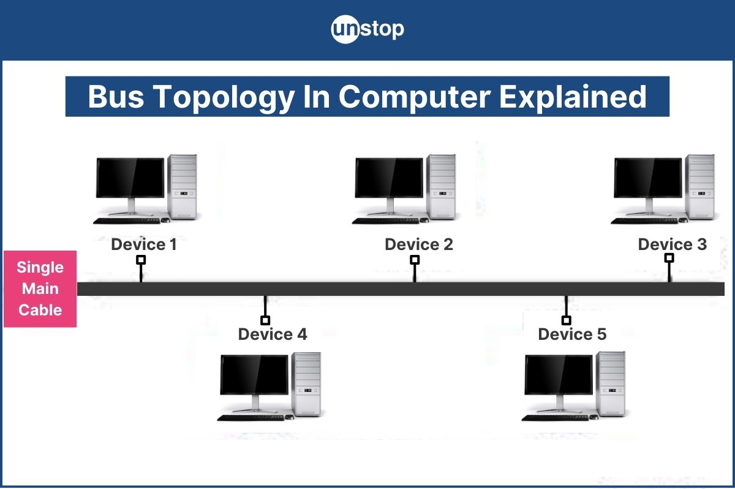

**Advantages:**

* Easy to implement and extend.
* Requires less cable compared to other topologies.
* Cost-effective for small networks.

**Disadvantages:**

* Limited cable length and number of devices.
* A failure in the main cable disrupts the entire network.
* Difficult to troubleshoot.

**2. Star Topology**

**Description:**

* All devices are connected to a central device, such as a **hub** or **switch**.
* Data passes through the central device to reach the destination.

**Diagram:**

Copy

Device 1

│

Device 2 ── Hub/Switch ── Device 3

│

Device 4

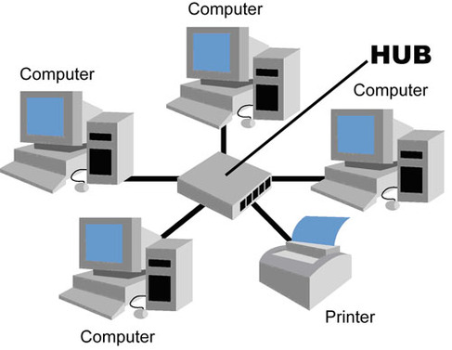

**Advantages:**

* Easy to install and manage.
* Failure of one device does not affect the rest of the network.
* Easy to troubleshoot.

**Disadvantages:**

* Requires more cable compared to bus topology.
* Failure of the central hub/switch disrupts the entire network.
* Can be expensive due to the cost of the central device.

**3. Ring Topology**

**Description:**

* Each device is connected to two other devices, forming a **circular data path**.
* Data travels in one direction (unidirectional) or both directions (bidirectional).

**Diagram:**

Copy

Device 1 ─── Device 2

│ │

Device 4 ─── Device 3

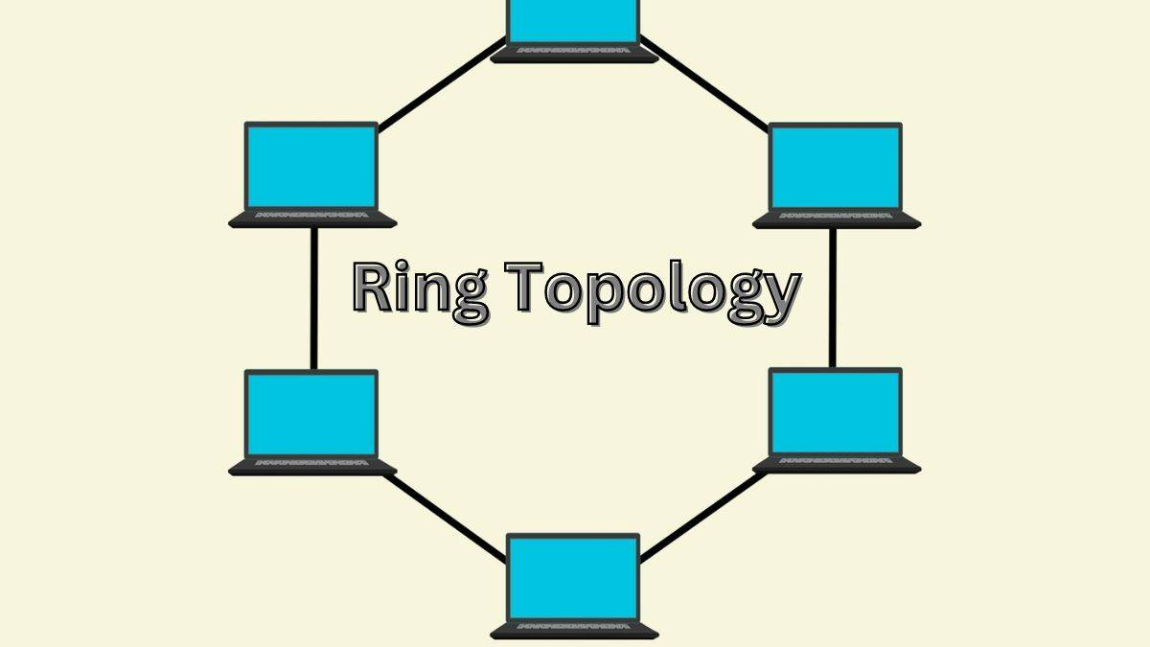

**Advantages:**

* Data packets travel at high speed.
* No collisions (in token-based ring networks).
* Easy to identify faults.

**Disadvantages:**

* A failure in any cable or device can disrupt the entire network.
* Difficult to add or remove devices.
* Requires more cable than bus topology.

**4. Mesh Topology**

**Description:**

* Each device is connected to every other device in the network.
* Can be **fully connected** (every device connects to every other device) or **partially connected** (some devices have multiple connections).

**Diagram:**

Copy

Device 1 ─── Device 2

│ \ / │

│ \ / │

Device 4 ─── Device 3

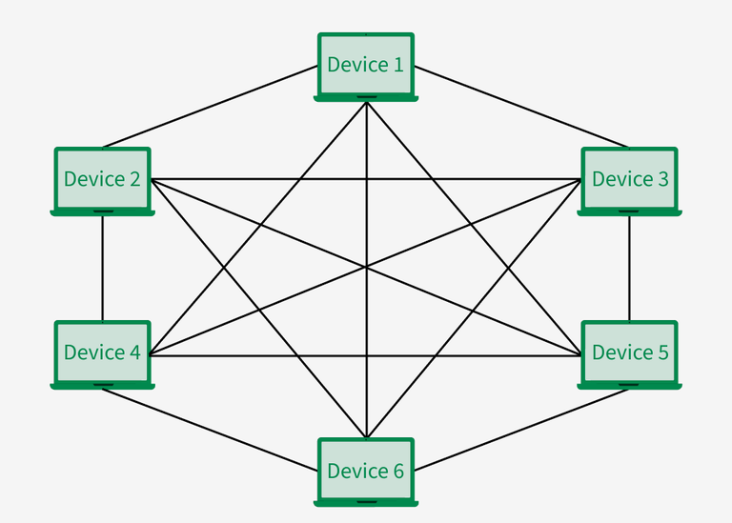

**Advantages:**

* High fault tolerance (multiple paths for data transmission).
* Reliable and robust.
* No traffic issues as data travels through dedicated links.

**Disadvantages:**

* Expensive due to the high number of cables and ports required.
* Complex to install and manage.
* Not scalable for large networks.

**5. Hybrid Topology**

**Description:**

* A combination of two or more different topologies.
* Designed to leverage the advantages of each topology while minimizing their disadvantages.

**Example:**

* A network with a **star backbone** and **bus sub-networks**.

**Diagram:**

Copy

Star Topology (Main Hub)

│

Bus Topology ─── Device 1 ─── Device 2

│

Ring Topology ─── Device 3 ─── Device 4

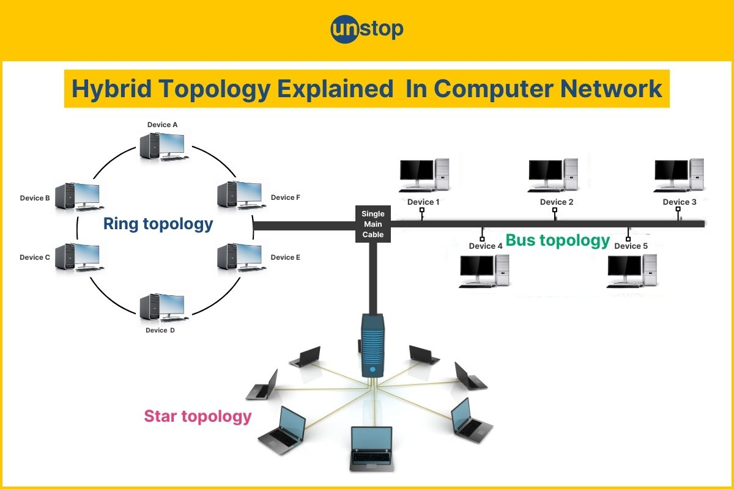

**Advantages:**

* Flexible and scalable.
* Can be customized to meet specific needs.
* Fault tolerance depends on the underlying topologies.

**Disadvantages:**

* Complex design and implementation.
* Can be expensive due to the combination of different topologies.
* Requires advanced planning.

|  |  |  |  |  |  |
| --- | --- | --- | --- | --- | --- |
| **Comparison of Topologies** | | | | | |
| **Topology** | **Cost** | **Scalability** | **Fault Tolerance** | **Ease of Setup** | **Use Case** |
| **Bus** | Low | Low | Low | Easy | Small networks |
| **Star** | Moderate | High | Moderate | Easy | Offices, homes |
| **Ring** | Moderate | Moderate | Low | Moderate | Small to medium networks |
| **Mesh** | High | Low | High | Difficult | Critical systems (e.g., military) |
| **Hybrid** | High | High | High | Difficult | Large, complex networks |

**Telecommunications Media**

Telecommunications media refer to the various channels or pathways through which data, voice, and video are transmitted from one point to another. These media can be broadly categorized into two types: **guided (wired)** and **unguided (wireless)** media. Each type has its own characteristics, advantages, and disadvantages, making them suitable for different applications.

**1. Guided (Wired) Media**

Guided media use physical pathways to transmit signals. The most common types include:

**a) Twisted Pair Cable**

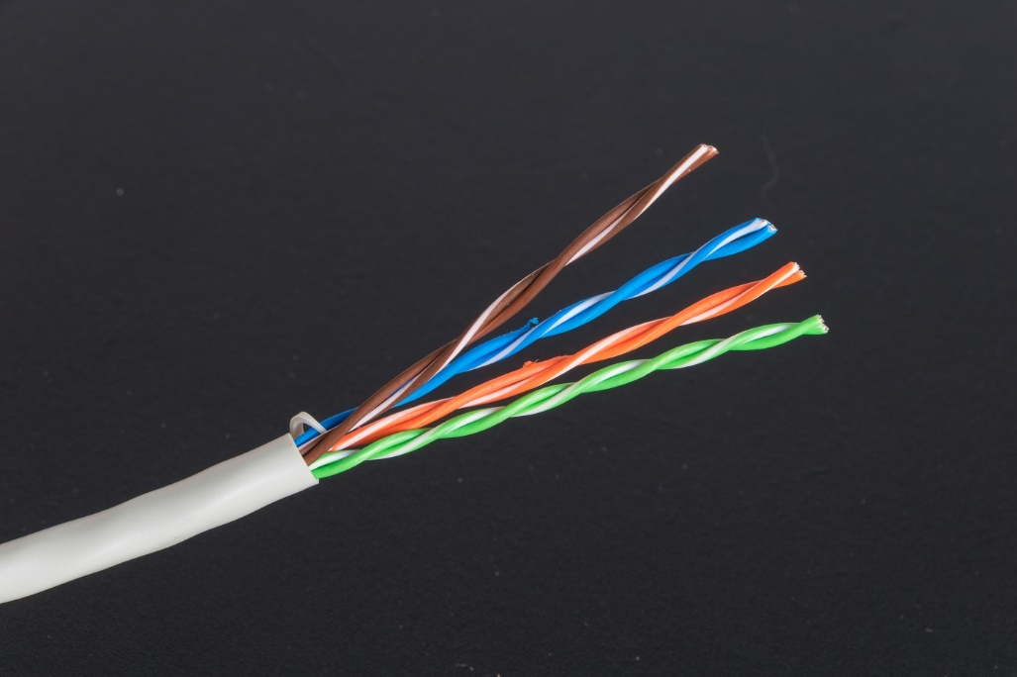

* **Description**: Consists of two insulated copper wires twisted together to reduce electromagnetic interference (EMI).
* **Types**:
  + **Unshielded Twisted Pair (UTP)**: Commonly used in Ethernet networks (e.g., Cat5, Cat6).
  + **Shielded Twisted Pair (STP)**: Has additional shielding to reduce interference, used in environments with high EMI.
* **Advantages**:
  + Inexpensive and easy to install.
  + Widely used in local area networks (LANs).
* **Disadvantages**:
  + Limited bandwidth and distance.
  + Susceptible to interference and crosstalk.
* **Applications**: Telephone networks, Ethernet LANs.

**b) Coaxial Cable**

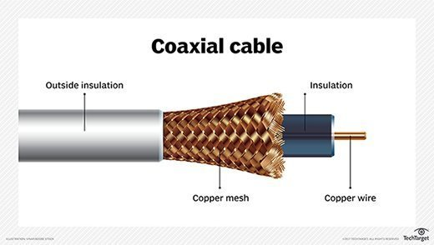

* **Description**: Consists of a central copper conductor surrounded by insulation, a metallic shield, and an outer insulating layer.
* **Advantages**:
  + Higher bandwidth than twisted pair.
  + Less susceptible to interference.
* **Disadvantages**:
  + More expensive and bulky than twisted pair.
  + Difficult to install in some environments.
* **Applications**: Cable television (CATV), broadband internet, older Ethernet networks.

**c) Fiber Optic Cable**

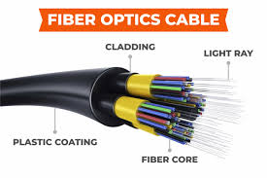

* **Description**: Uses light pulses to transmit data through thin glass or plastic fibers.
* **Types**:
  + **Single-mode fiber**: Allows one mode of light to propagate, used for long-distance communication.
  + **Multi-mode fiber**: Allows multiple modes of light, used for shorter distances.
* **Advantages**:
  + Extremely high bandwidth and data rates.
  + Immune to electromagnetic interference.
  + Low signal attenuation over long distances.
* **Disadvantages**:
  + Expensive to install and maintain.
  + Fragile and requires specialized equipment.
* **Applications**: Long-distance telecommunications, internet backbones, high-speed data networks.

**2. Unguided (Wireless) Media**

Unguided media transmit signals through the air or space without physical pathways. The most common types include:

**a) Radio Waves**

* **Description**: Electromagnetic waves with frequencies ranging from 3 kHz to 300 GHz.
* **Advantages**:
  + Can travel long distances and penetrate walls.
  + Easy to set up and cost-effective.
* **Disadvantages**:
  + Susceptible to interference and signal degradation.
  + Limited bandwidth compared to wired media.
* **Applications**: AM/FM radio, television broadcasting, Wi-Fi, Bluetooth.

**b) Microwaves**

* **Description**: High-frequency radio waves (1 GHz to 300 GHz) used for point-to-point communication.
* **Types**:
  + **Terrestrial microwaves**: Use ground-based towers for communication.
  + **Satellite microwaves**: Use satellites to relay signals over long distances.
* **Advantages**:
  + High bandwidth and data rates.
  + Suitable for long-distance communication.
* **Disadvantages**:
  + Requires line-of-sight for terrestrial microwaves.
  + Expensive infrastructure for satellite communication.
* **Applications**: Cellular networks, satellite TV, GPS.

**c) Infrared (IR)**

* **Description**: Uses infrared light waves for short-range communication.
* **Advantages**:
  + Secure and immune to electromagnetic interference.
  + Low cost and easy to implement.
* **Disadvantages**:
  + Limited range and requires line-of-sight.
  + Affected by obstacles and environmental conditions.
* **Applications**: Remote controls, short-range data transfer (e.g., IrDA).

**d) Satellite Communication**

* **Description**: Uses satellites in geostationary or low-earth orbit to relay signals.
* **Advantages**:
  + Global coverage, even in remote areas.
  + High bandwidth for data, voice, and video transmission.
* **Disadvantages**:
  + High latency (especially for geostationary satellites).
  + Expensive to launch and maintain.
* **Applications**: Global internet, television broadcasting, military communication.

**e) Laser Communication**

* **Description**: Uses laser beams to transmit data through the air or space.
* **Advantages**:
  + Extremely high data rates.
  + Secure and immune to interference.
* **Disadvantages**:
  + Requires precise alignment and clear line-of-sight.
  + Affected by atmospheric conditions.
* **Applications**: Space communication, high-speed data links.



**Factors Influencing Media Selection**

* **Bandwidth Requirements**: Higher bandwidth applications (e.g., video streaming) require fiber optics or microwaves.
* **Distance**: Long-distance communication may require satellites or fiber optics.
* **Cost**: Budget constraints may favor twisted pair or radio waves.
* **Environmental Conditions**: Interference, obstacles, and weather can affect wireless media.
* **Security**: Wired media like fiber optics offer better security than wireless options.

**5. Emerging Trends in Telecommunications Media**

* **5G Networks**: High-speed wireless communication with low latency.
* **Li-Fi**: Uses visible light for high-speed data transmission.
* **Quantum Communication**: Leverages quantum mechanics for ultra-secure communication.
* **Satellite Constellations**: Projects like Starlink aim to provide global internet coverage using low-earth orbit satellites.

**Conclusion**

Telecommunications media play a critical role in enabling communication across the globe. The choice of media depends on factors like bandwidth, distance, cost, and environmental conditions. As technology advances, new media and methods are emerging to meet the growing demand for faster, more reliable, and secure communication.